程序出处：

STM32Cube_FW_H7_V1.5.0\Projects\STM32H743I_EVAL\Applications\LwIP\LwIP_TCP_Echo_Server

功能：

使用Echo传输协议实现的TCP服务器的测试程序，程序将客户端发送过来的数据直接发送回去，主要用来测试客户端与服务器之间的网络传输速度。

测试方法：

* 为了方便测试，程序默认打开DHCP功能，即是可以自动获取IP地址。测试前先准备好一个打开DHCP功能的路由器，开发板及测试用的上位机均是连接到这个路由器上。
* 程序运行后液晶屏上显示获取到的IP地址，本次测试开发板获取到的IP地址为192.168.1.3。
* 运行\STM32H743xI-CD\Tools\TCPUDPDbg目录下TCPUDPDbg.exe网络调试软件，在弹出的对话框中连接类型选TCP，目标IP填开发板实际分配到的IP地址，本次测试开发板从路由器那里获取到的IP地址为192.168.1.3，端口填7，点击创建按钮创建连接。

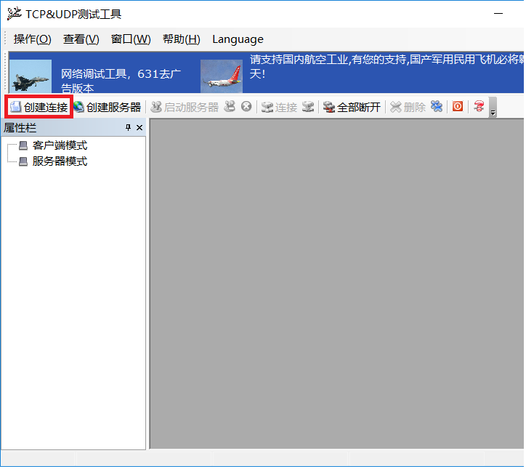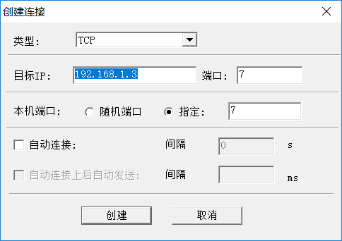

* 点击“连接”按钮连接开发板，在发送区域输入字符串点击“发送”按键将数据发送到开发板，接收区随即收到开发板返回来的数据：

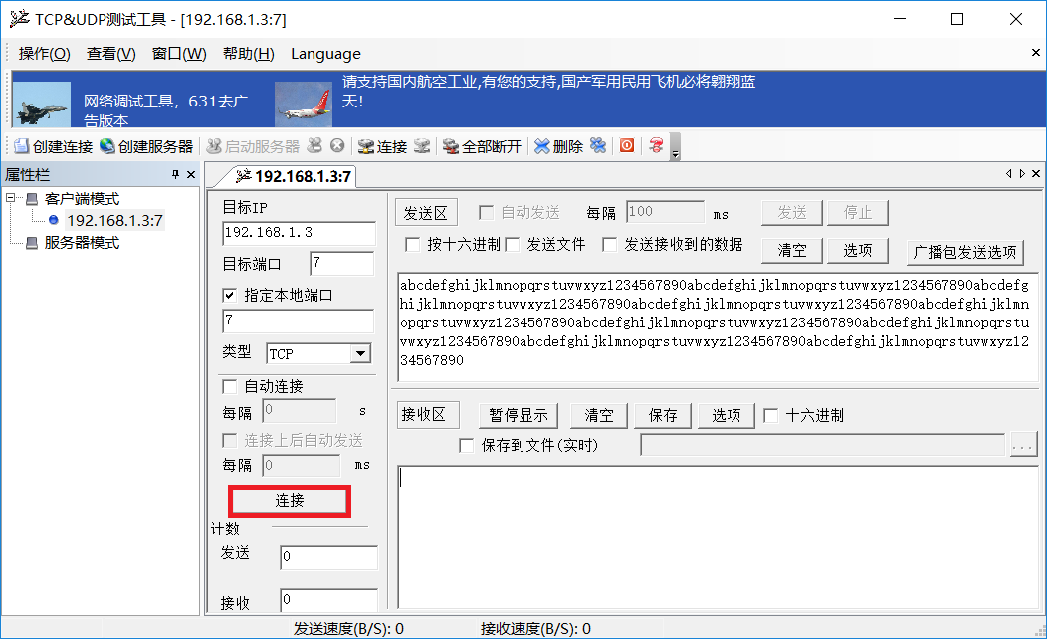

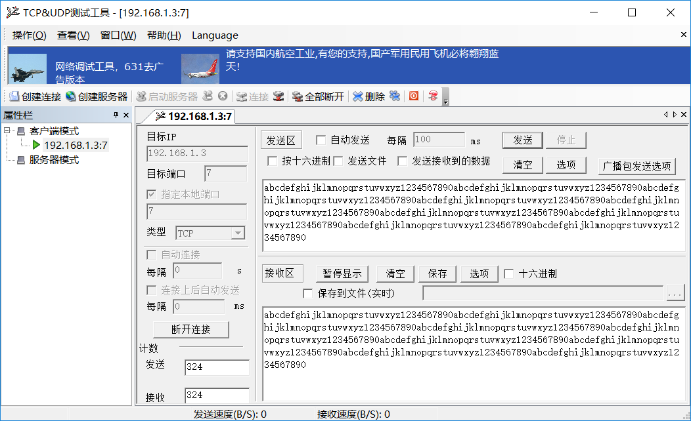

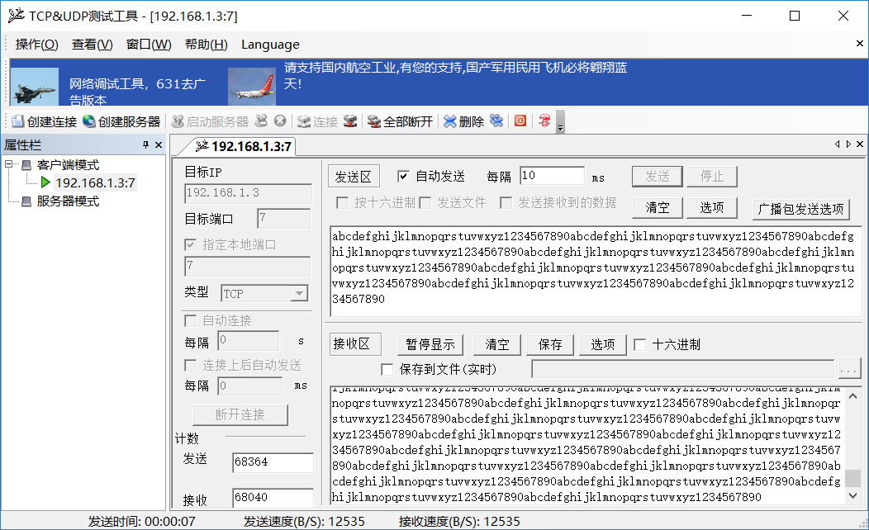

1. 按下图选M4内核的配置然后点击LOAD按钮下载M4内核的程序。

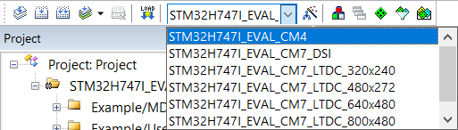

1. 按下图选M7内核的配置然后点击LOAD按钮下载M7内核的程序，M7内核的程序可以选择六种型号的液晶屏，带DSI字符的是MIPI接口的液晶屏，接20P的DSI接口。带LTDC字符的是RGB接口的液晶屏，接40P的RGB接口。

补充说明：

Echo Protocol

From Wikipedia, the free encyclopedia

The **Echo Protocol** is a service in the [Internet Protocol Suite](https://en.wikipedia.org/wiki/Internet_Protocol_Suite) defined in [RFC 862](https://tools.ietf.org/html/rfc862). It was originally proposed for testing and measurement of [round-trip times](https://en.wikipedia.org/wiki/Round-trip_time)in IP networks.

A host may connect to a server that supports the Echo Protocol using the [Transmission Control Protocol](https://en.wikipedia.org/wiki/Transmission_Control_Protocol) (TCP) or the [User Datagram Protocol](https://en.wikipedia.org/wiki/User_Datagram_Protocol) (UDP) on the [well-known](https://en.wikipedia.org/wiki/List_of_well-known_ports_(computing)) [port number](https://en.wikipedia.org/wiki/Port_number) 7. The server sends back an identical copy of the data it received.

Round-trip delay time

From Wikipedia, the free encyclopedia

In [telecommunications](https://en.wikipedia.org/wiki/Telecommunication), the **round-trip delay time** (**RTD**) or **round-trip time** (**RTT**) is the length of time it takes for a signal to be sent plus the length of time it takes for an acknowledgement of that signal to be received. This time delay includes the [propagation times](https://en.wikipedia.org/wiki/Propagation_time) for the paths between the two [communication endpoints](https://en.wikipedia.org/wiki/Communication_endpoint).

In [space technology](https://en.wikipedia.org/wiki/Space_technology), the round-trip delay time or **round-trip light time** is the time light (and hence any signal) takes to go to a [space probe](https://en.wikipedia.org/wiki/Space_probe) and return.

In the context of computer networks, the signal is generally a [data packet](https://en.wikipedia.org/wiki/Network_packet), and the RTT is also known as the **ping time**. An internet user can determine the RTT by using the [ping command](https://en.wikipedia.org/wiki/Ping_command).

[End-to-end delay](https://en.wikipedia.org/wiki/End-to-end_delay) is the length of time it takes for a signal travel one direction and is often approximated by half the RTT.